University of Rajshahi

Department of Computer Science and Engineering

B.Sc.Engg.Part-1 Odd Semester, Examination-2016

Course: APEE 1131 (Electrical Circuit and Electronics)

Time: 3Hrs. Full Marks : 52.5

[Answer SIX (06) questions taking at least THREE (03) from each Section]

Section A

1. (a) State and explain maximum power transfer theorem.

(b) Apply Thevenin’s theorem to calculate the current through the 5Ω resistor

of the circuit below:

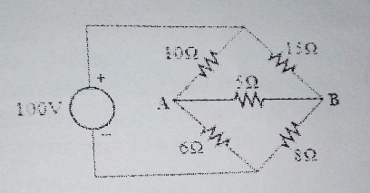

2.(a) State and explain Kirchoff’s current law with a suitable example.

(b) Distinguish between Thevenin’s and Norton’s theorem.

(c) Apply Norton’s theorem to calculate current flowing through the terminal AB

of the figure below:

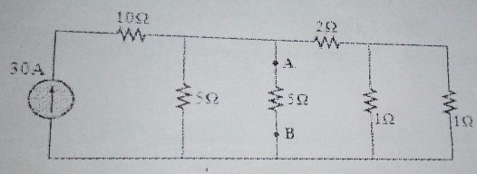

3.(a)What are the different kinds of filter?Explain each type with frequency response curve.

(b) Find out the characteristics impedance of a symmetrical T-section network.

(c) Draw and discuss the circuit diagram of a T-section low pass filter and find out it’s cut off

frequency.

4.(a) What is rectifier?How can you use a junction diode as a rectifier?

(b) Briefly discuss the operation of a full wave bridge rectifier .Show the effect of a shunt capacitor in

the rectifier.

(c) Explain the V-I characteristics of a zener diode.

Section B

5.(a) Draw the circuit diagram of an npn transistor in CE configuration and discuss its input and output

characteristics .

(b) What is load line?Show the importance of load line with proper diagram.

(c) Show the relationship between α and β.

(d) What is thermal Runaway? Define stability factor.

6.(a) What do you understand by transistor biasing ? Why is it needed?

(b) Draw the diagram of a base with emitter feedback circuit and explain its operation.

(c) In figure Vcc=12V,VBE=0.7V,RL=1K ohm,RB=100K ohm and β=100.Now find IC,VCE,IB and stability

Factor.

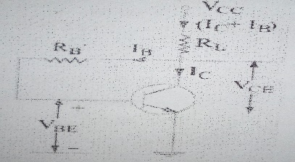

7.(a) What is feedback?Discuss the principle of a feedback amplifier?

(b) What is an oscillator? Define damped and undamped oscillator?

(c) Design a bistable multivibrator and discuss its operation.

8.(a) What is CMRR ? Write down some characteristics of an ideal OP-AMP.

(b) How an OP-AMP can be used as an integrator ?Explain.

(c) What is inverting and non-inverting amplifier? Explain with necessary figures.